1)using our own terms & diagrams,explain INCEPTIONNET Architecture .

Ans : An inception network is a deep neural network with an architectural design that consists of repeating components referred to as Inception module.Inception Modules are used in Convolutional Neural Networks to allow for more efficient computation and deeper Networks through a dimensionality reduction with stacked 1×1 convolutions. The modules were designed to solve the problem of computational expense, as well as overfitting, among other issues. The solution, in short, is to take multiple kernel filter sizes within the CNN, and rather than stacking them sequentially, ordering them to operate on the same level.

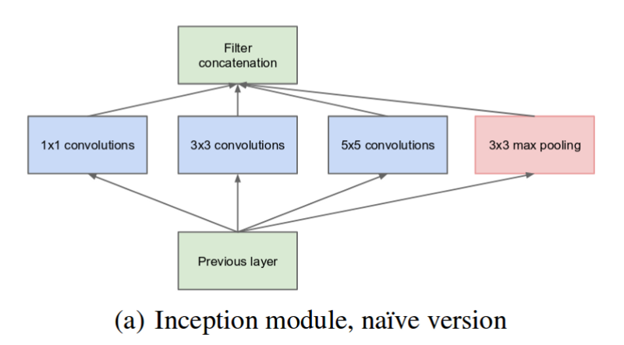

Inception Modules are incorporated into convolutional neural networks (CNNs) as a way of reducing computational expense. As a neural net deals with a vast array of images, with wide variation in the featured image content, also known as the salient parts, they need to be designed appropriately. The most simplified version of an inception module works by performing a convolution on an input with not one, but three different sizes of filters (1x1, 3x3, 5x5). Also, max pooling is performed. Then, the resulting outputs are concatenated and sent to the next layer. By structuring the CNN to perform its convolutions on the same level, the network gets progressively wider, not deeper.

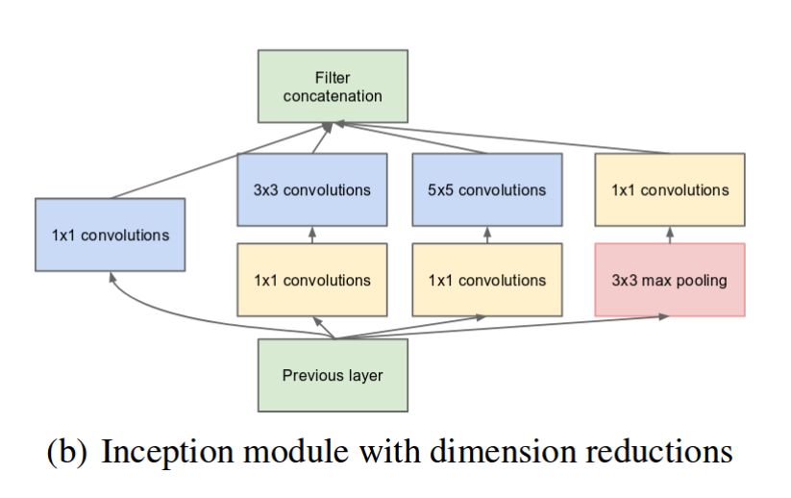

To make the process even less computationally expensive, the neural network can be designed to add an extra 1x1 convolution before the 3x3 ad 5x5 layers. By doing so, the number of input channels is limited and 1x1 convolutions are far cheaper than 5x5 convolutions. It is important to note, however, that the 1x1 convolution is added after the max-pooling layer, rather than before.

The design of this initial Inception Module is known commonly as GoogLeNet, or Inception v1. Additional variations to the inception module have been designed, reducing issues such as the vanishing gradient problem.

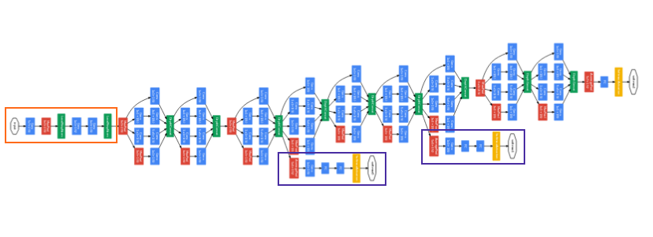

2)describe the inception block.

Ans : An Inception Module is an image model block that aims to approximate an optimal local sparse structure in a CNN. simply it allows for us to use multiple types of filter size, instead of being restricted to a single filter size in a single image block, which we then concatenate and pass onto the next layer.

3)what is the dimensionality Reduction layer(1 layer convolutional)?

Ans : Dimensionality reduction is a machine learning or statistical technique of reducing the amount of random variables in a problem by obtaining a set of principal variables.

4)The impact of Reducing dimensionality on network performance.

Ans : Dimensionality reduction refers to techniques for reducing the number of input variables in training data. When dealing with high dimensional data, it is often useful to reduce the dimensionality by projecting the data to a lower dimensional subspace which captures the “essence” of the data.

5)mention three Components. style googlenet.

Ans : GoogLeNet is a 22-layer deep convolutional neural network that's a variant of the Inception Network, a Deep Convolutional Neural Network developed by researchers at Google.

GoogLeNet is a convolutional neural network that is 22 layers deep. You can load a pre trained version of the network trained on either the ImageNet or Places365 data sets. The network trained on ImageNet classifies images into 1000 object categories, such as keyboard, mouse, pencil, and many animals.

GoogleNet possesses seven million parameters and contains nine inception modules, four convolutional layers, four max-pooling layers, three average pooling layers, five fully-connected layers, and three softmax layers for the main auxiliary classifiers in the network.

6)using our own terms diagrams,explain RESNET architecture.

Ans : A residual neural network (ResNet) is an artificial neural network (ANN). It is a gateless or open-gated variant of the HighwayNet, the first working very deep feedforward neural network with hundreds of layers, much deeper than previous neural networks.ResNet is a powerful backbone model that is used very frequently in many computer vision tasks. ResNet uses skip connection to add the output from an earlier layer to a later layer. This helps it mitigate the vanishing gradient problem.There are many variants of ResNet architecture i.e. same concept but with a different number of layers. We have ResNet-18, ResNet-34, ResNet-50, ResNet-101, ResNet-110, ResNet-152, ResNet-164, ResNet-1202 etc

RESNET's mission is to make the energy use for all homes transparent, thereby driving residential sector energy use toward net zero.Each ResNet block is either two layers deep (used in small networks like ResNet 18, 34) or 3 layers deep (ResNet 50, 101, 152).

Advantages of ResNet

Networks with large number of layers can be trained easily without increasing the training error percentage. ResNets help in tackling the vanishing gradient problem using identity mapping.ResNet can classify 1000 classes from the ImageNet dataset.

The decision boundaries for ResNet appear strikingly different: despite the even narrower width of one, from 2 hidden layers onwards, the ResNet represents the indicator of a bounded region.

ResNet addresses this network by introducing two types of 'shortcut connections': Identity shortcut and Projection shortcut. Resnet18 has around 11 million trainable parameters. It consists of CONV layers with filters of size 3x3 (just like VGGNet).In ResNet models, all convolutional layers apply the same convolutional window of size 3 × 3, the number of filters increases following the depth of networks, from 64 to 512 (for ResNet-18 and ResNet-34), from 64 to 2048 (for ResNet-50, ResNet-101, and ResNet-152).A building block of a ResNet is called a residual block or identity block. A residual block is simply when the activation of a layer is fast-forwarded to a deeper layer in the neural network.

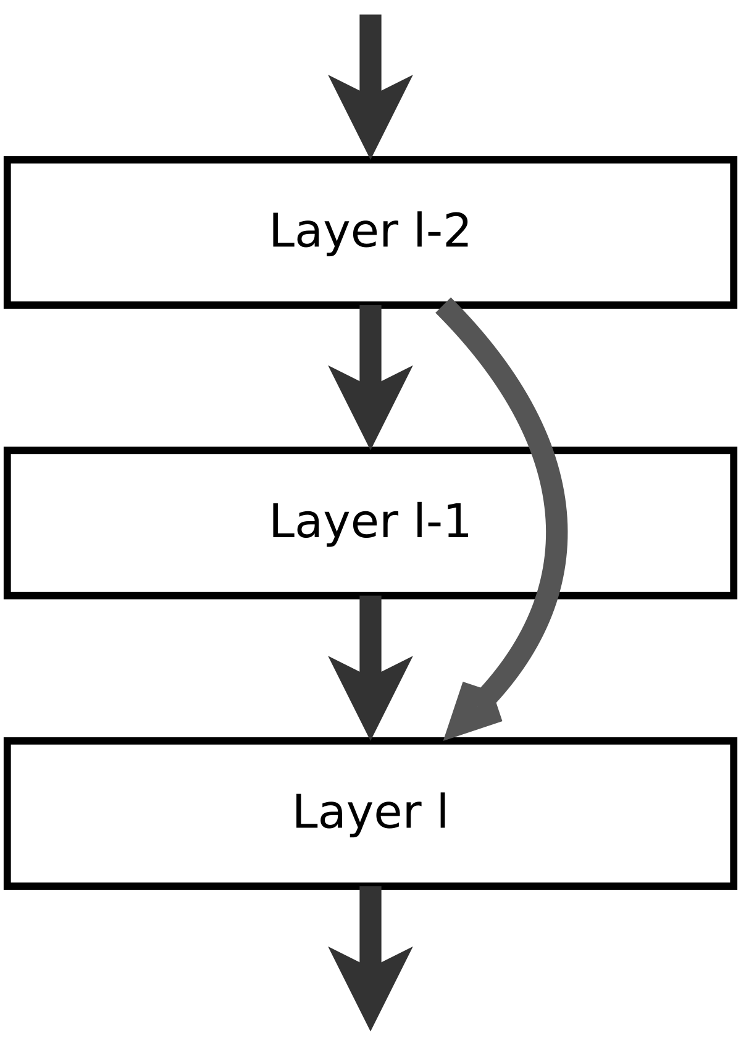

7)what do skip connections entail.

Ans : Skip Connections (or Shortcut Connections) as the name suggests skips some of the layers in the neural network and feeds the output of one layer as the input to the next layers. Skip Connections were introduced to solve different problems in different architectures.Skip connections were introduced in literature even before residual networks. For example, Highway Networks had skip connections with gates that controlled and learned the flow of information to deeper layers. This concept is similar to the gating mechanism in LSTM.Although ResNets is actually a special case of Highway networks, the performance isn’t up to the mark comparing to ResNets. This suggests that it’s better to keep the gradient highways skip connections can be used through the non-sequential layer in two ways: addition and concatenation. Let us learn about the two types of skip connections that use these two ways

Residual Networks (ResNets): skip connections using addition:

The data from the early layers are transferred to deeper layers in ResNets through matrix addition, hence the backpropagating is done through addition.

Because the output from the preceding layer is added to the layer ahead, this operation requires no extra parameters. The main mechanism of ResNets is to stack the skip residual blocks together and use an identity function to preserve the gradient.Due to the deeper layer representation of ResNets, the pre-trained weights of the network can be used to solve several tasks. It is not only restricted to image classification, but it can also address a broad variety of image segmentation, keypoint identification, and object recognition problems. As a result, ResNet is regarded as one of the most important designs in the deep learning community.

Densely Connected Convolutional Networks (DenseNets): skip connections using concatenation:

Low-level information is exchanged between the input and output, and it would be preferable to transfer this information directly across the network. Concatenation of prior feature maps is another method for achieving skip connections.DenseNet is the most well-known deep learning architecture. Huang et al. suggested DenseNets in 2017. The primary distinction between ResNets and DenseNets is that DenseNets concatenates the layer's output feature maps with the next layer rather than summarising them.The aim of concatenation is to leverage characteristics acquired in previous levels in deeper layers as well. This is referred to as Feature Reusability. As there is no need to learn redundant maps, DenseNets may learn mapping with fewer parameters than a standard Convolutional Neural Network. The concatenation leads to a huge amount of feature channels on the last layers of the network and extreme future reusability.Other than the two types of skip connections mentioned above, there are a few other skip connections worth mentioning. Before introducing additive skip connections in any deep learning model, we have to be careful as apart from the specified channel dimension, the dimensionality must be the same in addition and concatenation. There are two kinds of setups where additive skip connections are used: Short skip connections and Long skip connections.

Short skip connections are often employed in conjunction with consecutive convolutional layers that do not modify the input dimension, such as ResNet, whereas lengthy skip connections are typically seen in encoder-decoder architectures. It is well understood that global information (image shape and other statistics) resolves “what”, whereas local information resolves “where” (small details in an image patch).

Long skip connections are common in symmetrical designs, where temporal dimensionality is lowered in the encoder and subsequently increased in the decoder, as seen below. Transpose convolutional layers in the decoder can be used to enhance the dimensionality of a feature map. The transposed convolution process creates the same connectivity as the regular convolution operation, but in the other direction.

Finally, skip connections allow for feature reuse while also stabilizing training and convergence.

8)what is the Definition of residual block ?

Ans : A building block of a ResNet is called a residual block or identity block. A residual block is simply when the activation of a layer is fast-forwarded to a deeper layer in the neural network.residual blocks allow memory (or information) to flow from initial to last layers. Despite the absence of gates in their skip connections, residual networks perform as well as any other highway network in practice.

9)how can transfer learning help with Problems.

Ans : Transfer learning helps developers take a blended approach from different models to fine-tune a solution to a specific problem. The sharing of knowledge between two different models can result in a much more accurate and powerful model. The approach allows for the building models in an iterative way.

Transfer learning is a technique to help solve this problem. As a concept, it works by transferring as much knowledge as possible from an existing model to a new model designed for a similar task. For example, transferring the more general aspects of a model which make up the main processes for completing a task. This could be the process behind how objects or images are being identified or categorized. Extra layers of more specific knowledge can then be added to the new model, allowing it to perform its task in new environments.

10)what is the transfer Learning and how does it work.?

Ans : Transfer learning is a machine learning technique where a model trained on one task is re-purposed on a second related task.Transfer learning is an optimization that allows rapid progress or improved performance when modeling the second task.Transfer learning is related to problems such as multi-task learning and concept drift and is not exclusively an area of study for deep learning.

transfer learning is popular in deep learning given the enormous resources required to train deep learning models or the large and challenging datasets on which deep learning models are trained.

Two common approaches are as follows:

Develop Model Approach

Pre-trained Model Approach

Develop Model Approach

Select Source Task. You must select a related predictive modeling problem with an abundance of data where there is some relationship in the input data, output data, and/or concepts learned during the mapping from input to output data.

Develop Source Model. Next, you must develop a skillful model for this first task. The model must be better than a naive model to ensure that some feature learning has been performed.

Reuse Model. The model fit on the source task can then be used as the starting point for a model on the second task of interest. This may involve using all or parts of the model, depending on the modeling technique used.

Tune Model. Optionally, the model may need to be adapted or refined on the input-output pair data available for the task of interest.

Pre-trained Model Approach

Select Source Model. A pre-trained source model is chosen from available models. Many research institutions release models on large and challenging datasets that may be included in the pool of candidate models from which to choose from.

Reuse Model. The model pre-trained model can then be used as the starting point for a model on the second task of interest. This may involve using all or parts of the model, depending on the modeling technique used.

Tune Model. Optionally, the model may need to be adapted or refined on the input-output pair data available for the task of interest.

11) how do neural networks learn features.

Ans : Neural networks work by propagating forward inputs, weights and biases. However, it’s the reverse process of backpropagation where the network actually learns by determining the exact changes to make to weights and biases to produce an accurate result.Training a neural network involves using an optimization algorithm to find a set of weights to best map inputs to outputs. The problem is hard, not least because the error surface is non-convex and contains local minima, flat spots, and is highly multidimensional.

12)why is the fine tuning better than startup training

Ans : Fine Tuning means taking weights of a trained neural network and use it as initialization for a new model being trained on data from the same domain (often e.g. images). It is used to: speed up the training. overcome small dataset size.